**W1D4**

**QUESTION 1.**

**Write a Java program to solve the subset problem.**

1. **T or F.**

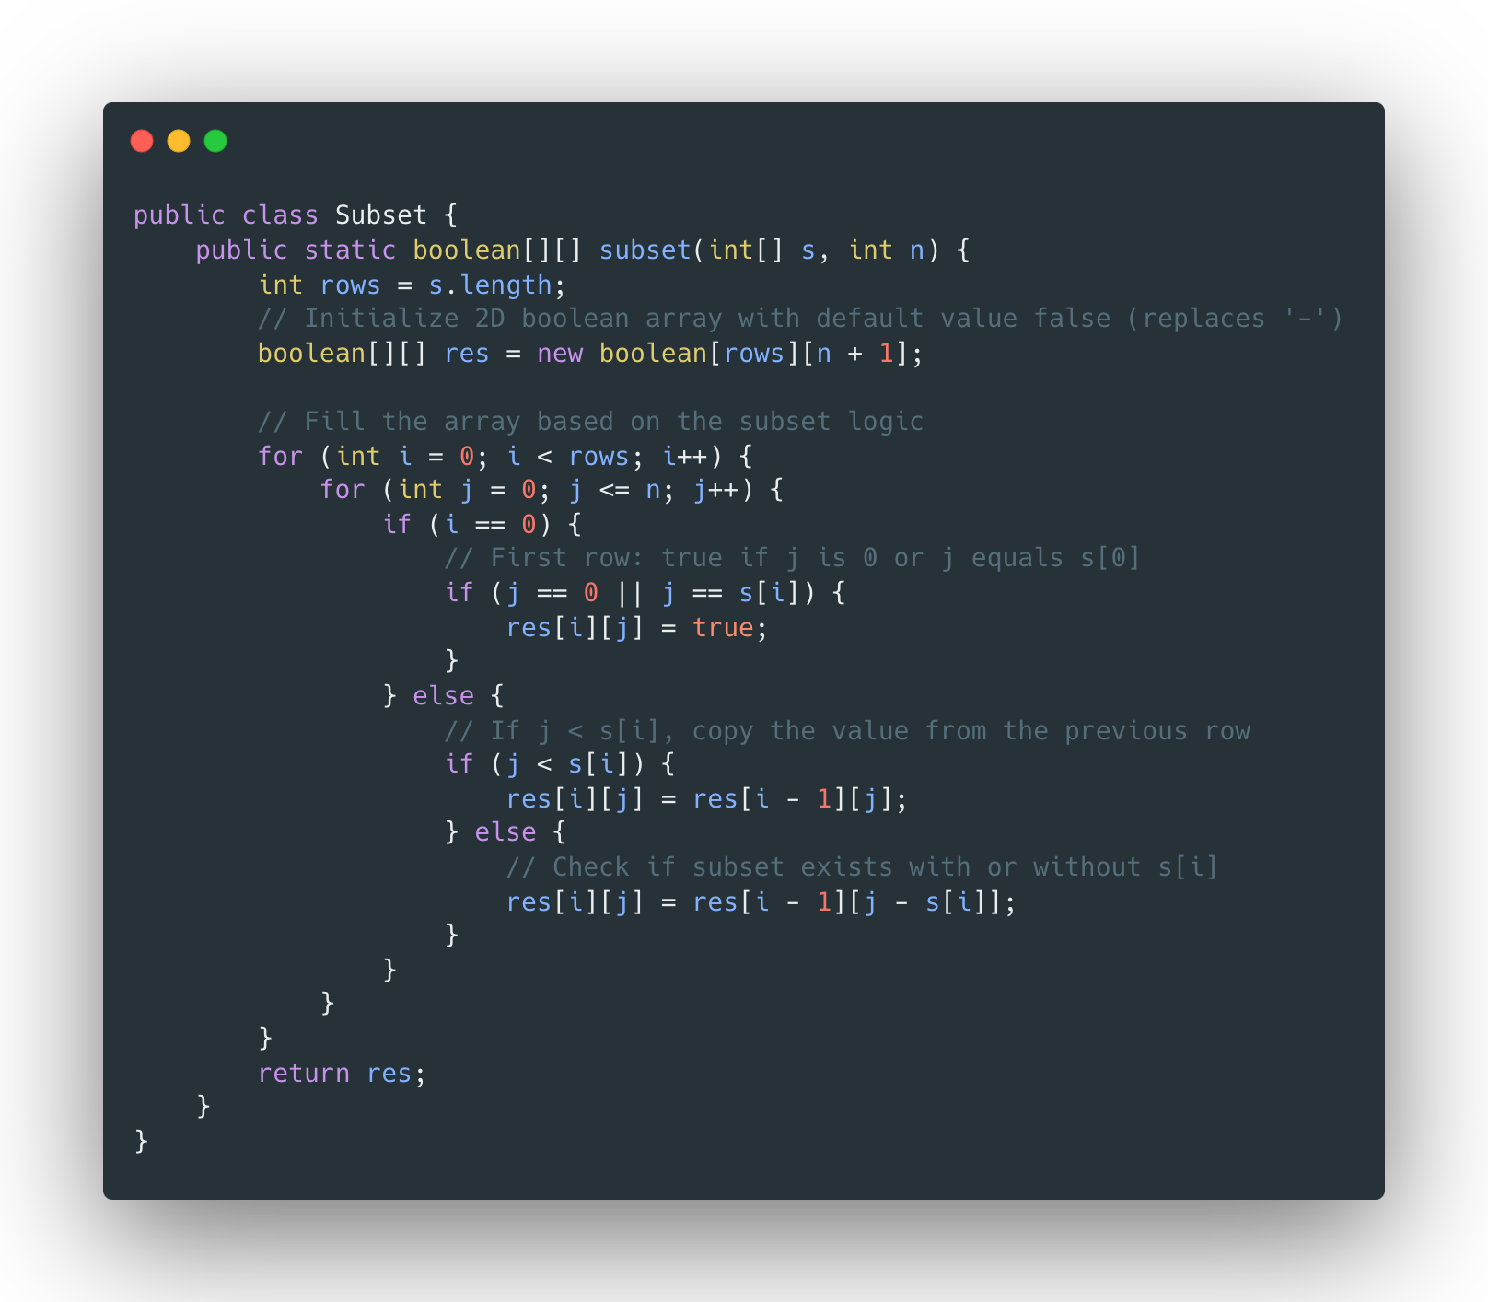

1. **One solution.**

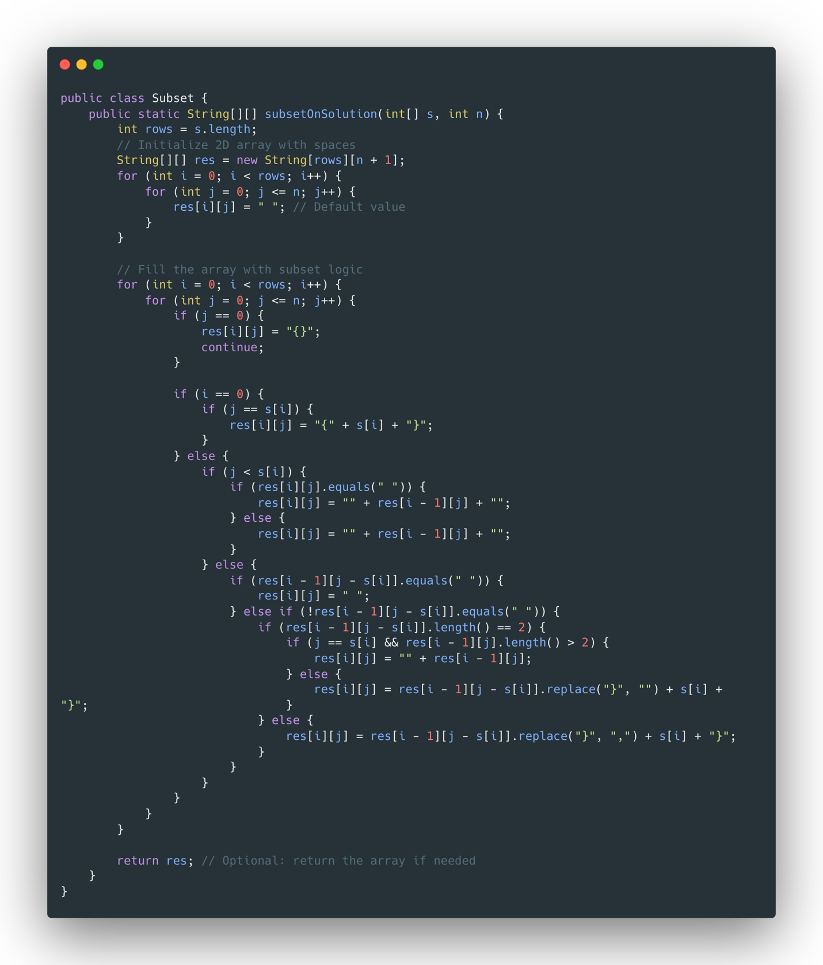

1. **All solutions.**

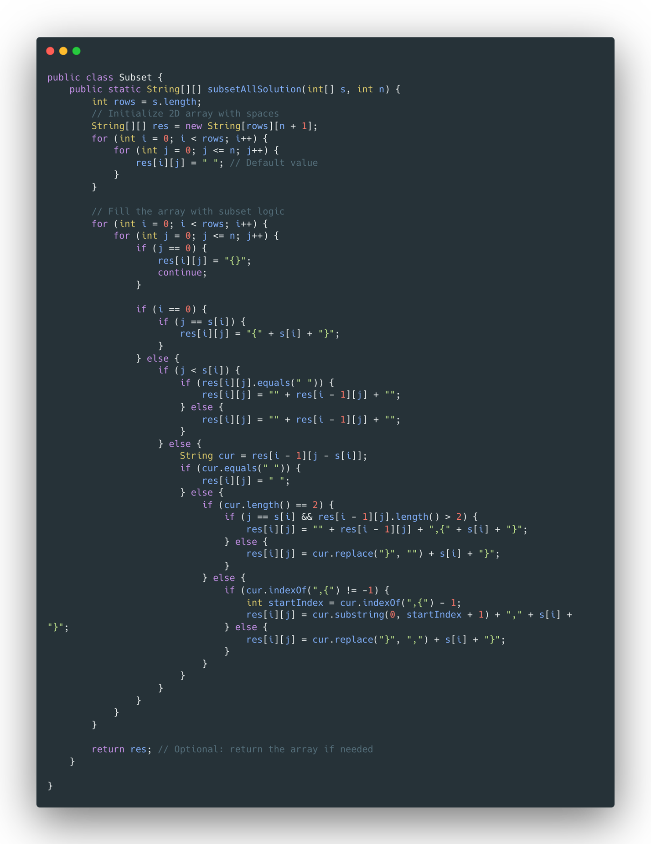

**QUESTION 2.**

**Solve subset problem where S = {3, 4, 7, 8} and k = 15.**

1. **T or F.**
2. **One solution.**
3. **All solutions.**

**QUESTION 3**

**Solve the integer Knapsack problem given below:**

***The maximum allowable total weight in the knapsack is Wmax = 20.***

|  |  |  |  |  |  |
| --- | --- | --- | --- | --- | --- |
| **Item** | **a** | **b** | **c** | **d** | **e** |
| **value** | **25** | **12** | **24** | **16** | **28** |
| **Weight** | **5** | **6** | **8** | **2** | **7** |

**QUESTION 4. Solve the fractional Knapsack problem given below:**

***The maximum allowable total weight in the knapsack is Wmax = 20.***

|  |  |  |  |  |  |
| --- | --- | --- | --- | --- | --- |
| **Item** | **a** | **b** | **c** | **d** | **e** |
| **value** | **25** | **12** | **24** | **16** | **28** |
| **Weight** | **5** | **6** | **8** | **2** | **7** |

**QUESTION 5.**

[**https://leetcode.com/problems/climbing-stairs/description/**](https://leetcode.com/problems/climbing-stairs/description/)

**QUESTION 6.**

[**https://leetcode.com/problems/house-robber/description/**](https://leetcode.com/problems/house-robber/description/)